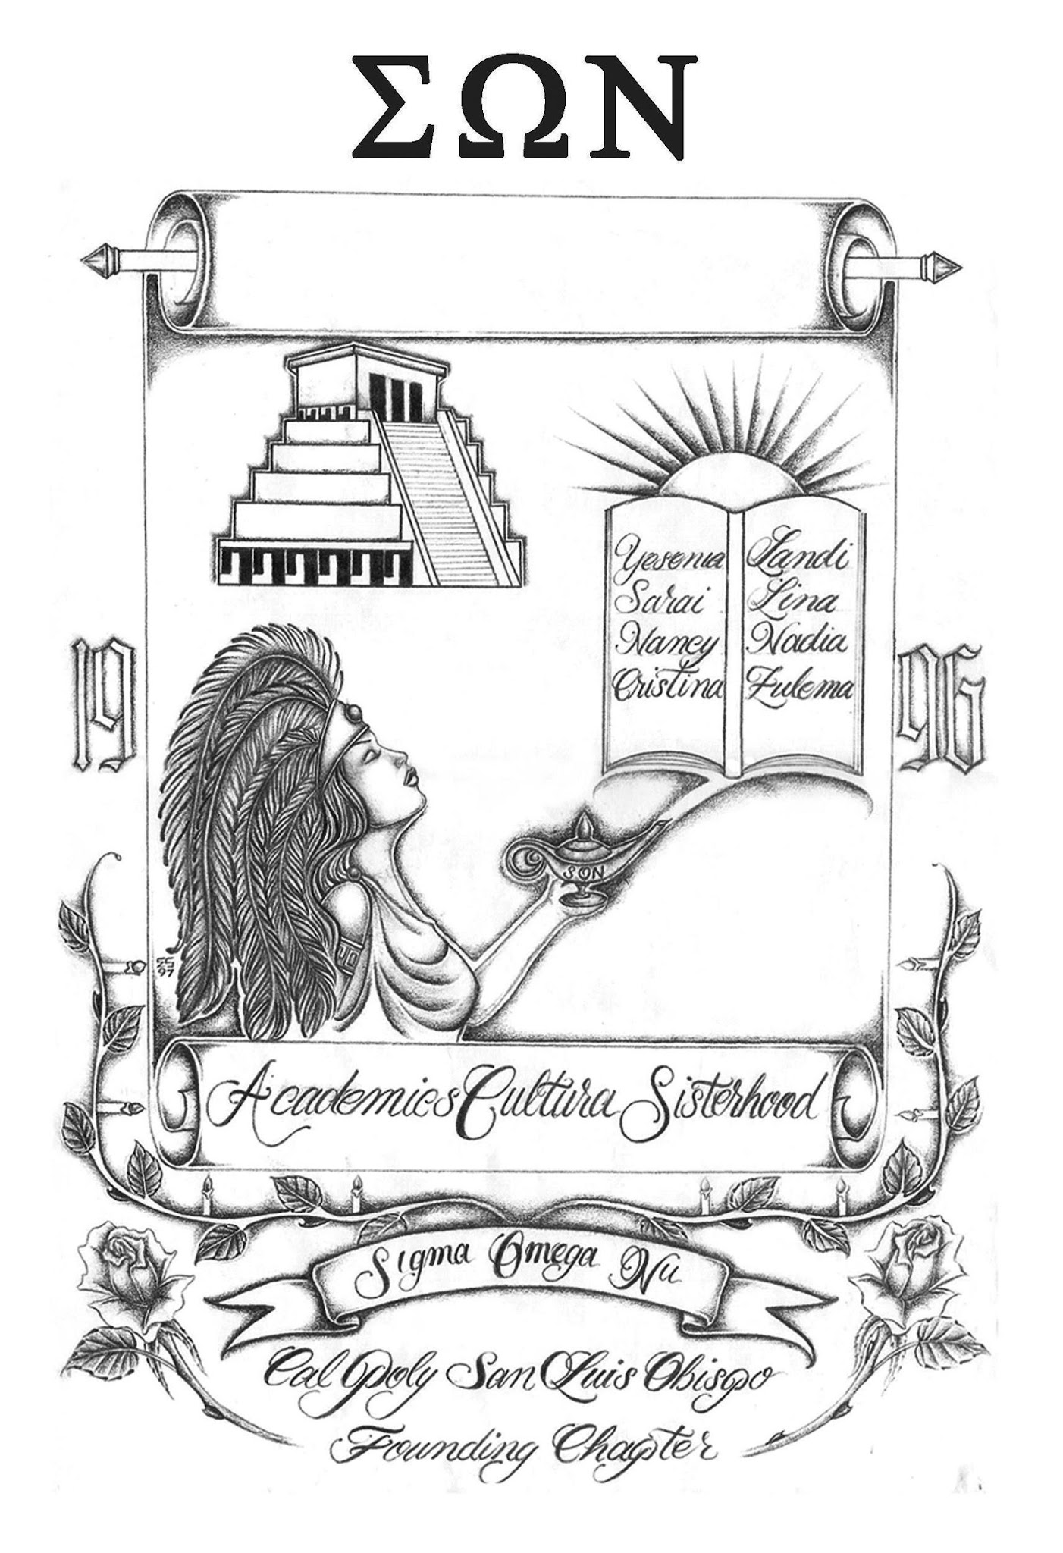
SIGMA OMEGA NU
LATINA INTEREST SORORITY
California State University Monterey Bay
Theta Chapter

Agenda

Date:
Meeting Call to Order:

Founder’s Chant:
“Academics, cultura, and sisterhood are the things we hold true and we shall remain faithful to the letter of Sigma Omega Nu. The sun, a symbol of our existence. White and yellow roses, the sign of pure friendship. Black, burgundy, and gold, the colors we represent which tell our story. For all the struggles we may face, together we will live, learn, and celebrate that which unites us as hermanas.”

Roll Call:
Attendees:
Absent:
Late:
Other Attendees:

Approval of Minutes:
Motion to Approve:
Second:
Vote:

Approval of Agenda:
Motion to Approve:
Second:
Vote:

- Business
  - Action Items

- Officer Reports
  - President ()
  - Vice President ()
  - Sergeant At Arms ()
  - Treasurer ()
  - VP of Communications ()
  - Risk Management ()
  - Cultura & Sisterhood ()
  - Community Service ()
  - Fundraising ()
  - Social Affairs ()
  - Public Relations ()
  - Historian ()
  - Pledge Mother ()
  - University Representative(s) ()
  - National Board Representative(s) ()
  - Alumnae Relations ()
- Old Business
- Reminders: N/A
- Announcements:

Meeting Adjourned: 1:00pm

Active Roster Fall 2023

Officer Information - sonthetachapter@gmail.com
President | sonthetachapterpresident@gmail.com
Vice President | sonthetachapter.vicepresident@gmail.com
Sergeant-At-Arms | sonthetachapter.sergeant@gmail.com
Treasurer | thetachaptertreasure08@gmail.com
VP of Communications | sonthetachapter.communications@gmail.com
Auditor | sonthetachapter.auditor@gmail.com
Cultura and Sisterhood | sonthetachapter.cultura@gmail.com
Community Service | sonthetachapter.service@gmail.com
Fundraising | sonthetachapter.fundraising@gmail.com
Alumnae Relations | sonthetachapter.alumnae@gmail.com
Social Affairs | sonthetachapter.social@gmail.com
Public Relations | sonthetachapter.pr@gmail.com
Historian | sonthetachapter.historian@gmail.com
Pledge Mother | sonthetachapter.pmom@gmail.com
University Representative | sonthetachapter.mgc@gmail.com
National Board Representative | sonthetachapter.nbrep@gmail.com

